5th of June 2025
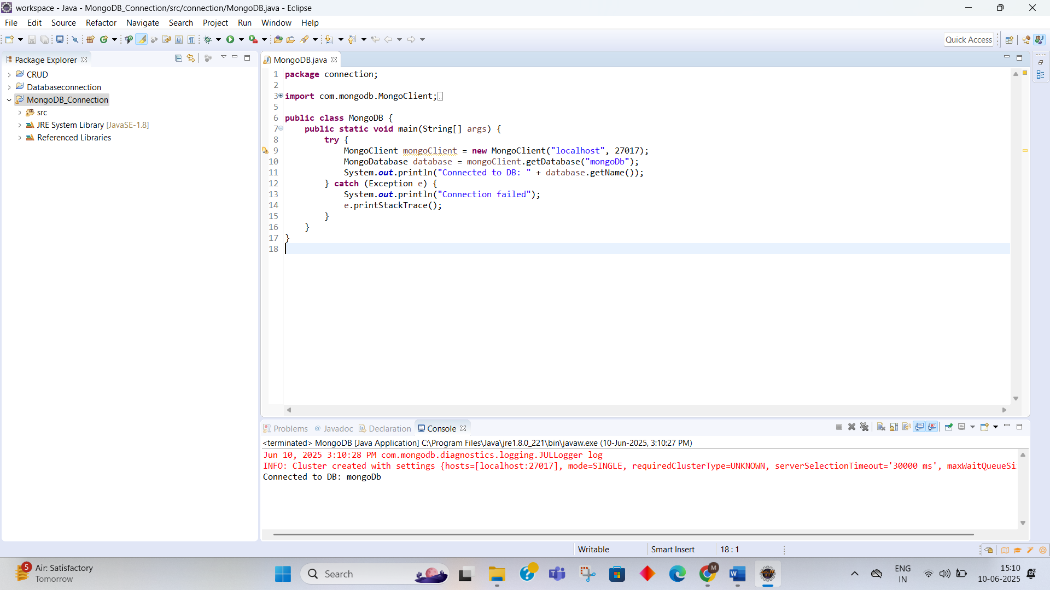
This Java program connects to a MongoDB database using the MongoClient class. It tries to connect to a database named "mongoDb" on localhost at port 27017. If the connection is successful, it prints the database name; otherwise, it handles and displays the error.

